**A Project Report On**

**MOVIE TICKET BOOKING**

FOR AISSCE 2022 EXAMINATION

[AS A PART OF COMPUTER SCIENCE COURSE]

**SUBMITTED BY-**

NAME: SUKRITI SINGH

ROLL NO: 63

**[UNDER THE GUIDANCE OF**

**MS. P.DEEPTI (HOD)]**

**CERTIFICATE**

This is to certify that **SUKRITI SINGH** of class XII-B has successfully completed the project work under guidance of Ms. P.Deepti. She has done her work all in original and finished it in due course of time as per CBSE guidelines.

**NAME: SUKRITI SINGH**

**Class: XII**

**Section: B(Non-Medical)**

**HOD Principal**

**Ms. P.Deepti MS. Monika Mehan**

**ACKNOWLEDGEMENT**

I undertook this project work, as the part of my XII CS course. I had tried to apply my best knowledge and experience, gained during and class work experience. However, developing software is generally a quite complex and time-consuming process. It requires a systematic study, insight vision and professional approach during the design and development. Moreover, the developer always feels the need, the help and good wishes of the people near you, who have considerable experience and idea.

I would like to extend my sincere thanks and gratitude to my teacher **Ms. P. Deepti** , for giving valuable time and moral support to develop this software.

I also feel indebted to my friends for the valuable suggestions during the project work.

* Project Introduction
* What is Python?
* Explanation of .CSV file
* Python Code
* Outputs
* MySQL Program
* After Insertion of Record (Python and MySQL)
* After Deletion of Record (Python and MySQL)
* Summary

**CONTENT**

The project objective is to book cinema tickets digitally. This project firstly asks us to enter a query in which we can book a ticket or cancel the booked ticket. If we are booking a ticket, it will ask our theatre choice first and then it will provide an id to us which is our user id. Then it will ask which movie we want to watch, total no. of tickets we want to book, our name and our preferred seating. After this the data is saved in respective database and it shows that tickets are booked.

If we want to cancel a ticket, it will ask our name, the theatre choosed and our user id. Then the data is removed from the respective database and it prints the tickets are cancelled successfully.

**INTRODUCTION**

Python is an interpreted, high-level, general-purpose programming language. Created by Guido van Rossum and first released in 1991, Python's design philosophy emphasizes code readability with its notable use of significant whitespace.



**WHAT IS PYTHON**

**WHAT IS .CSV FILE**

A comma-separated values file is a delimited text file that uses a comma to separate values. Each line of the file is a data record. Each record consists of one or more fields, separated by commas. The use of the comma as a field separator is the source of the name for this file format.

**PYTHON CODE**

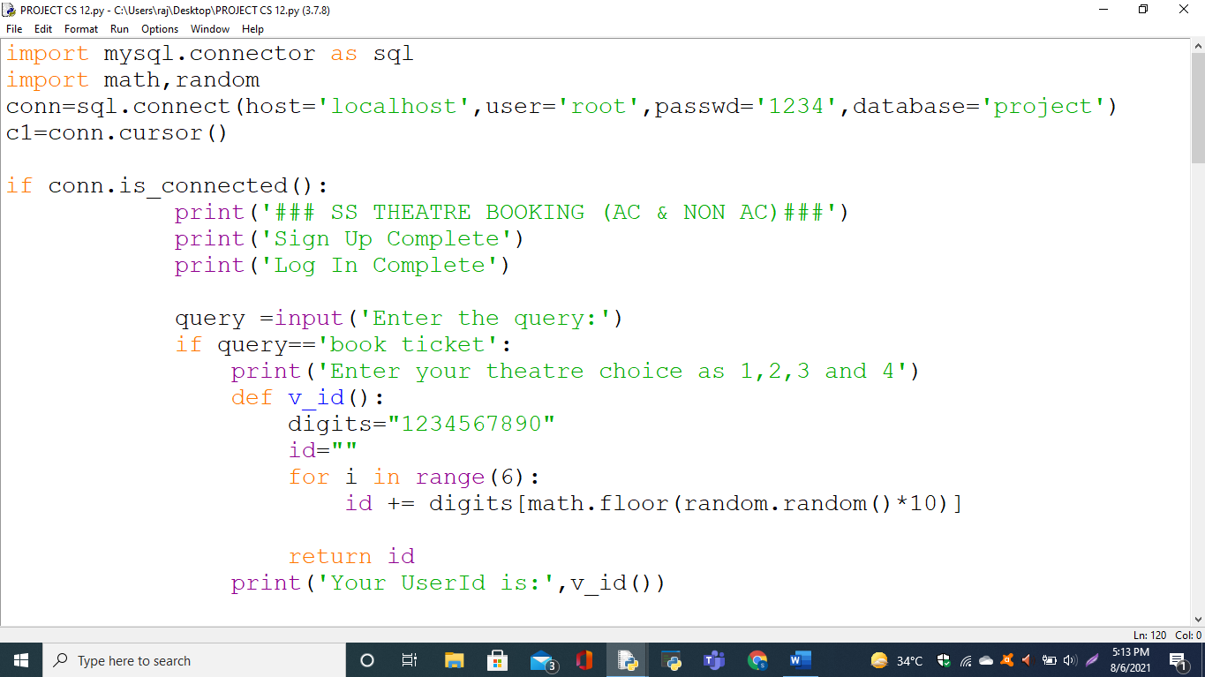

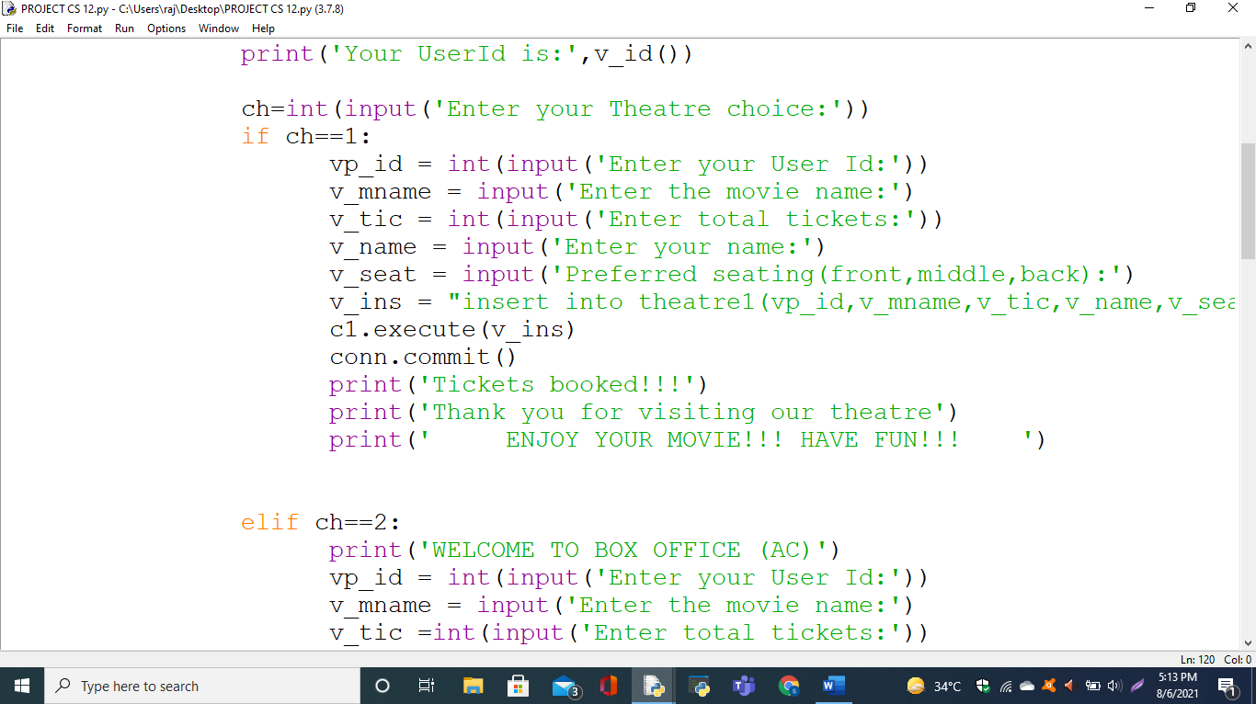

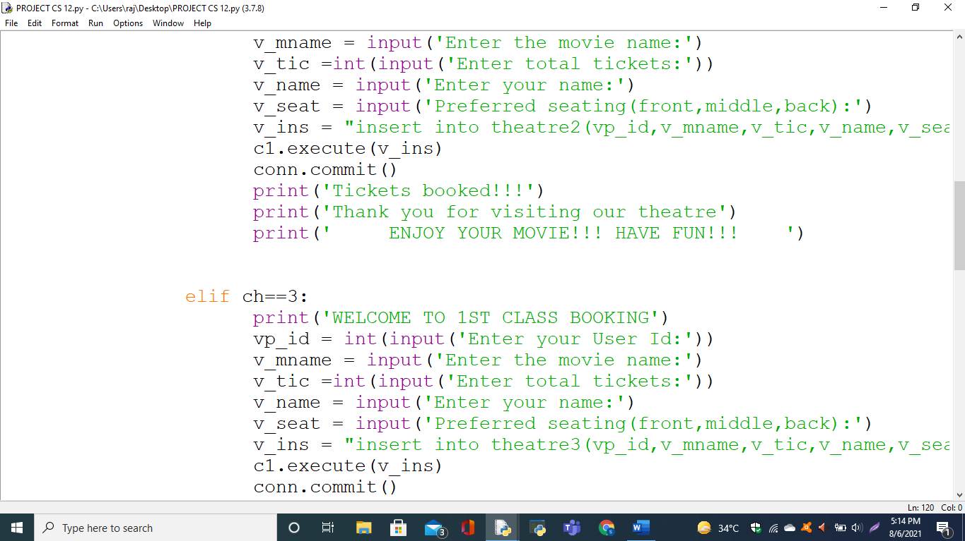

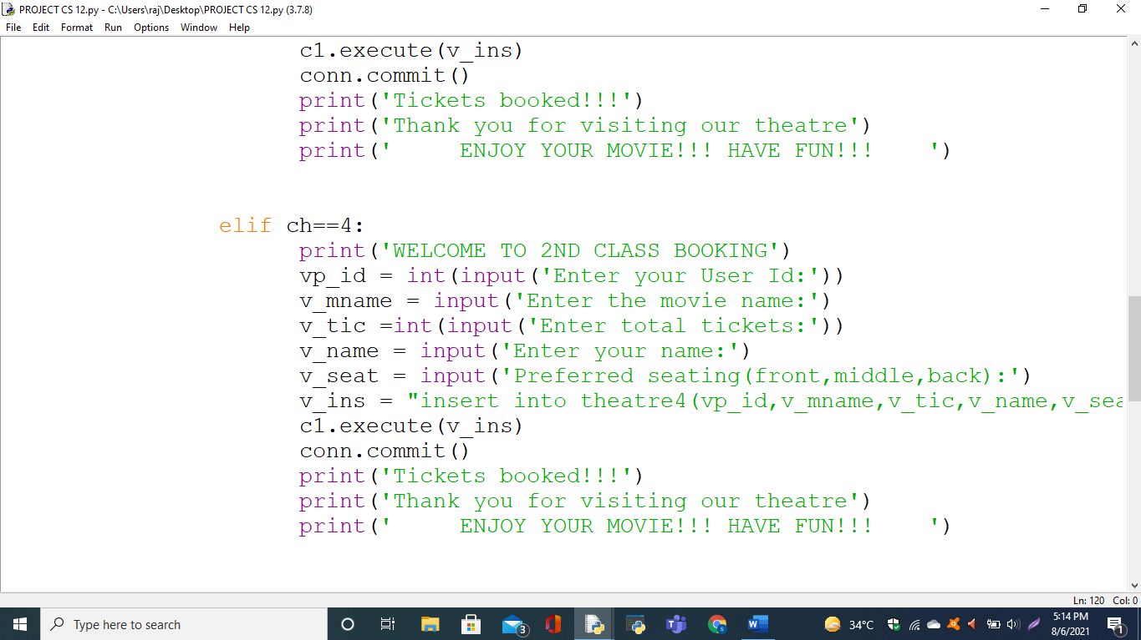

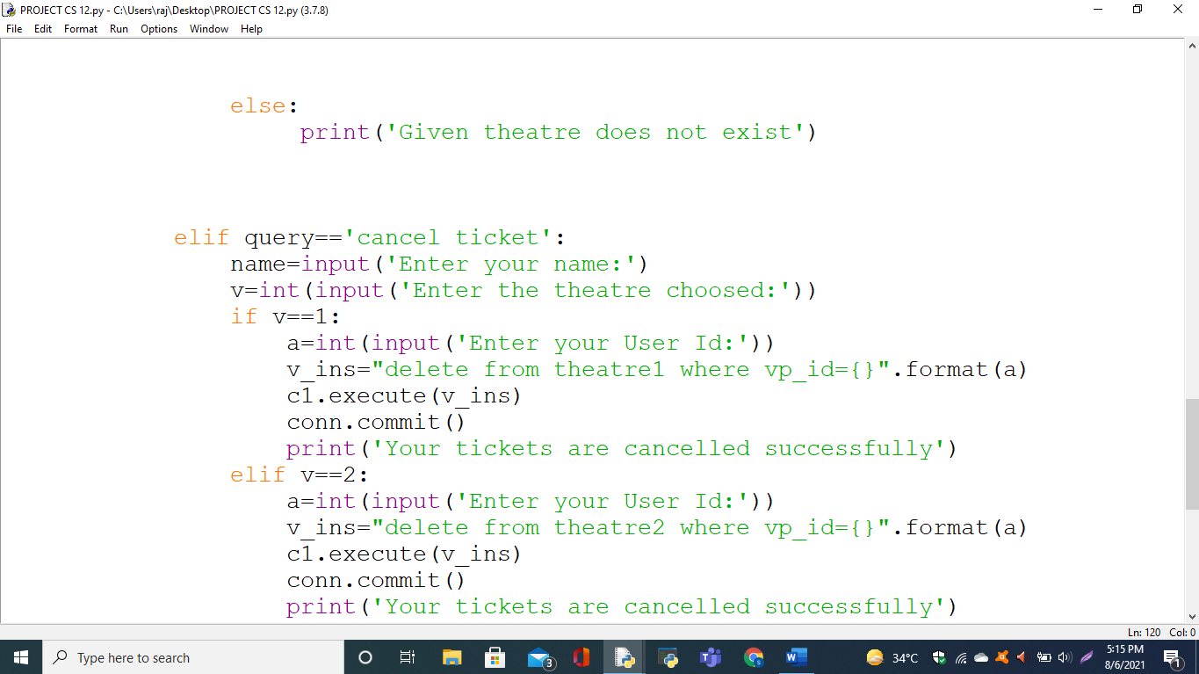

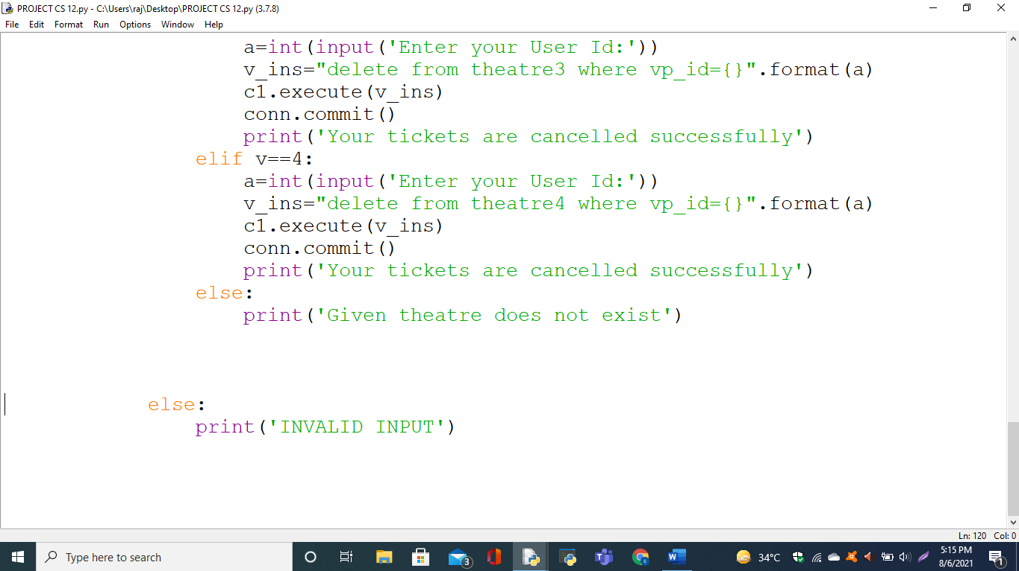

**OUTPUT**

**FOR BOOKING TICKET:**

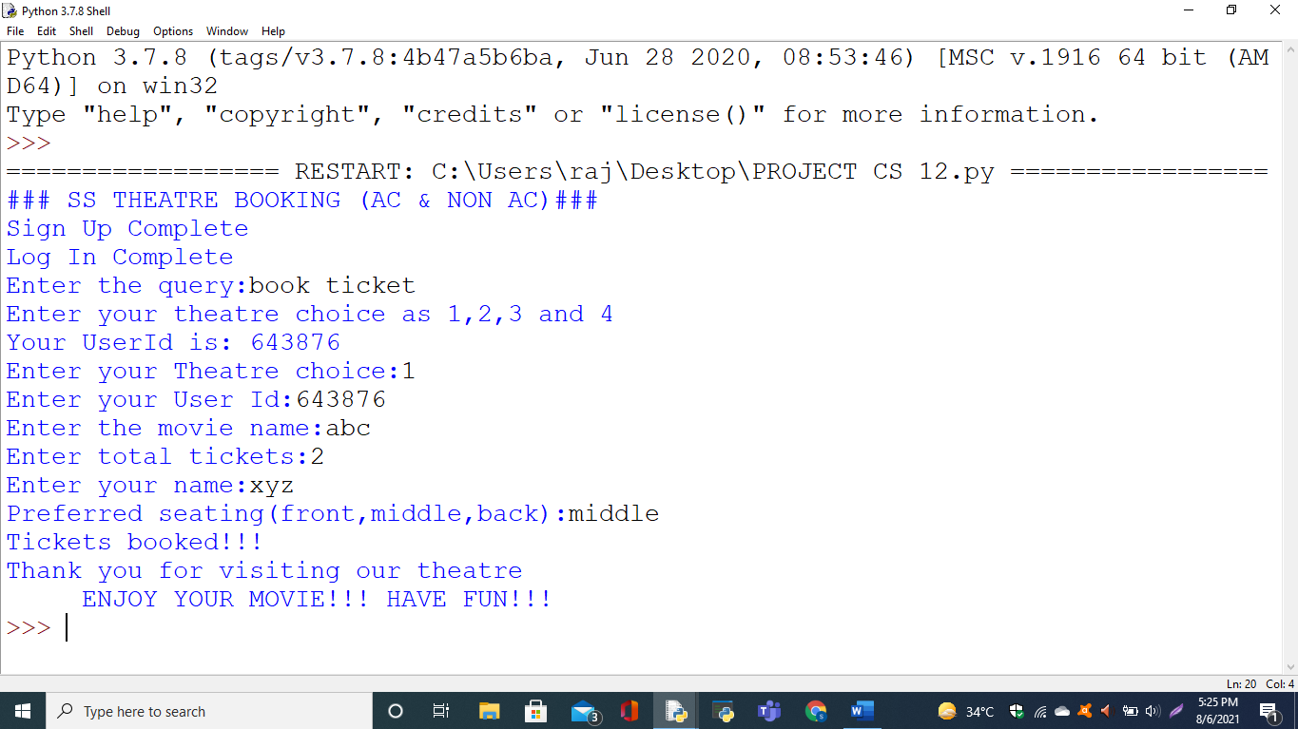

**FOR CANCELLING TICKET:** 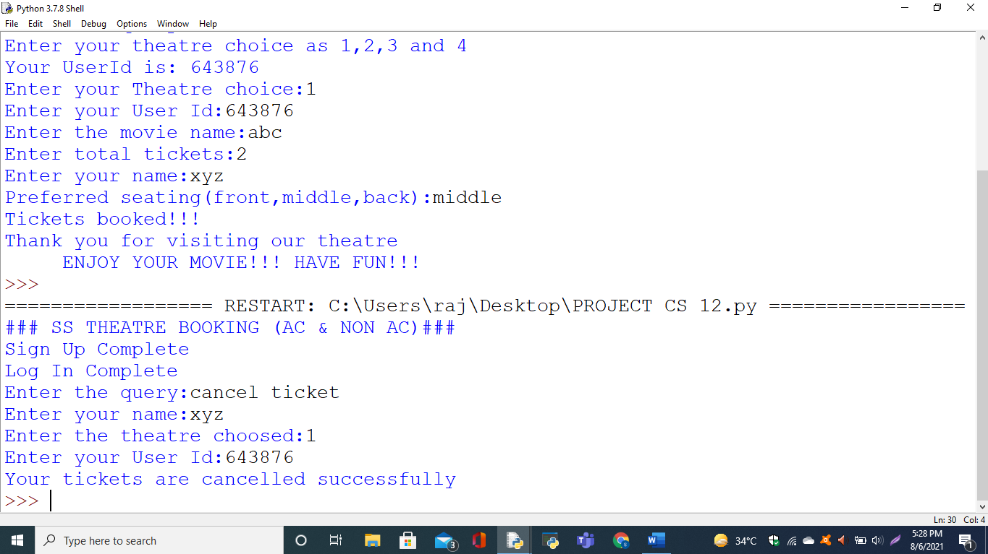

**MySQL OUTPUT**

**OPENING MySQL:**

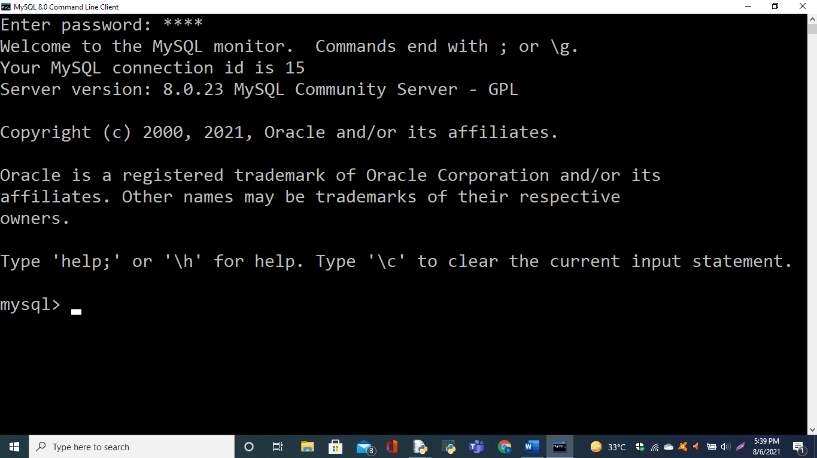

**SELECTING DATABASE:**

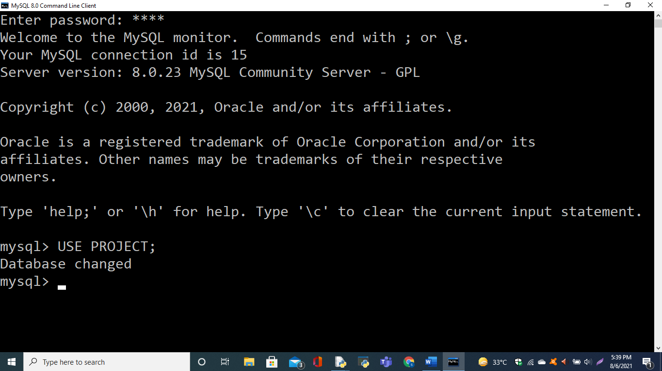

**SHOWING TABLES:**

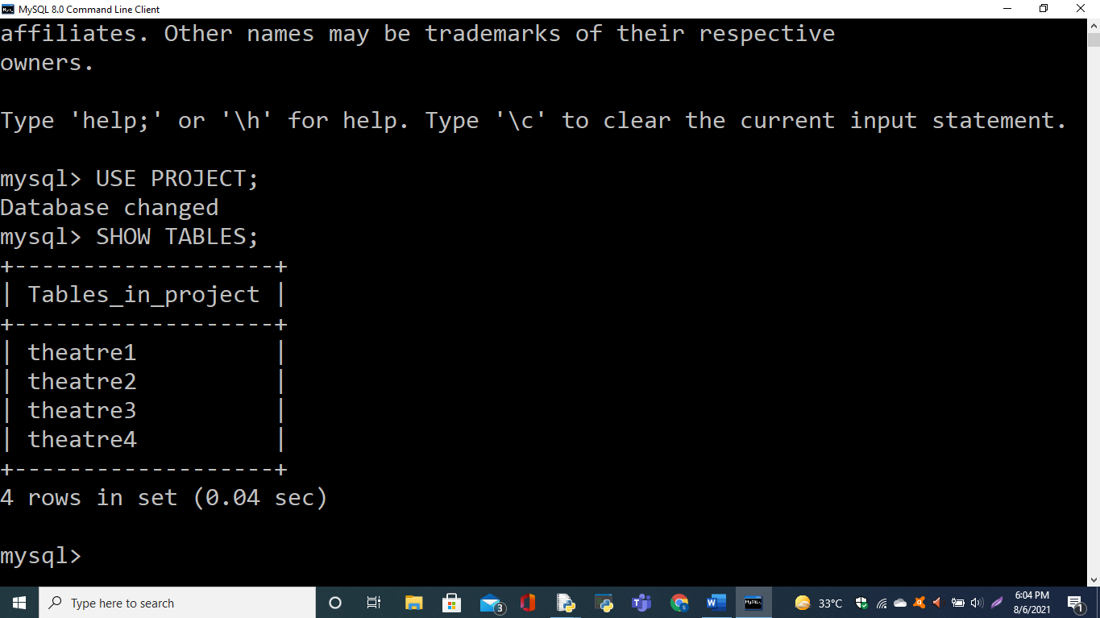

**DESCRIBING TABLE:**

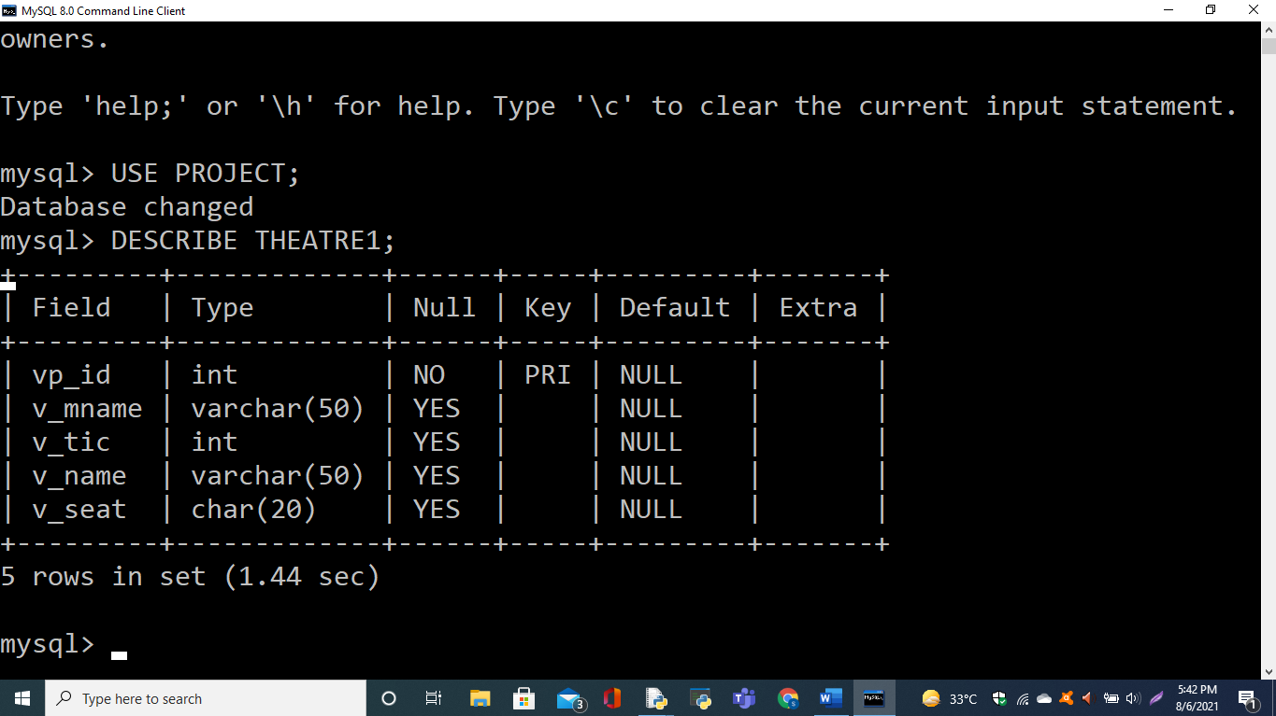

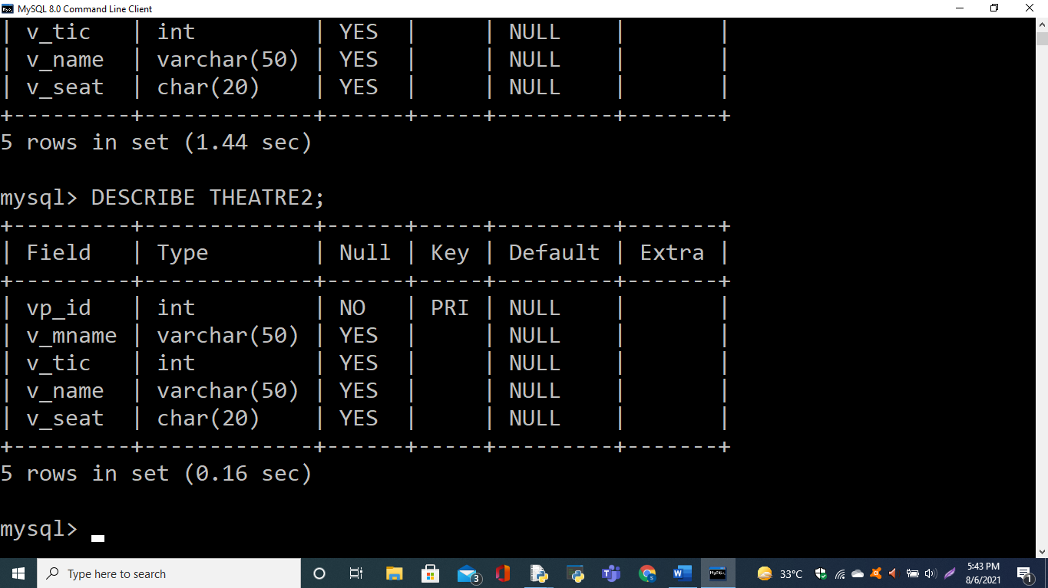

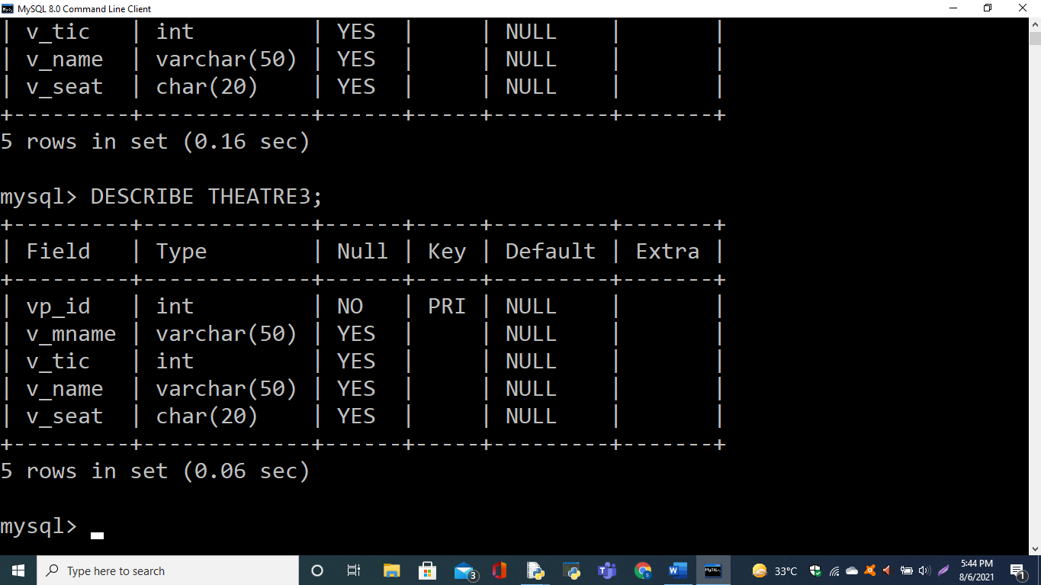

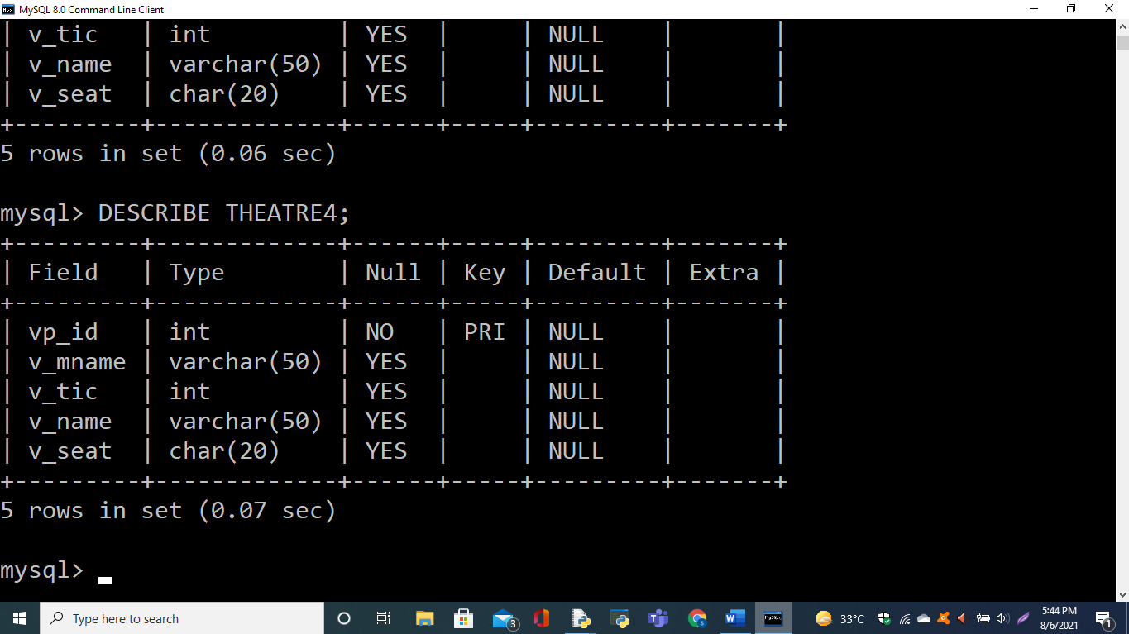

**SHOWING ENTRIES IN TABLES:**

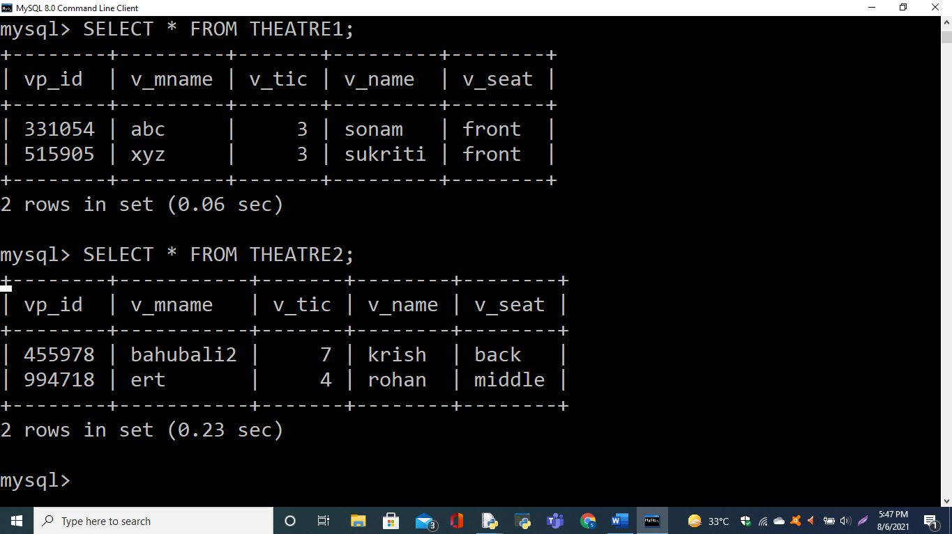

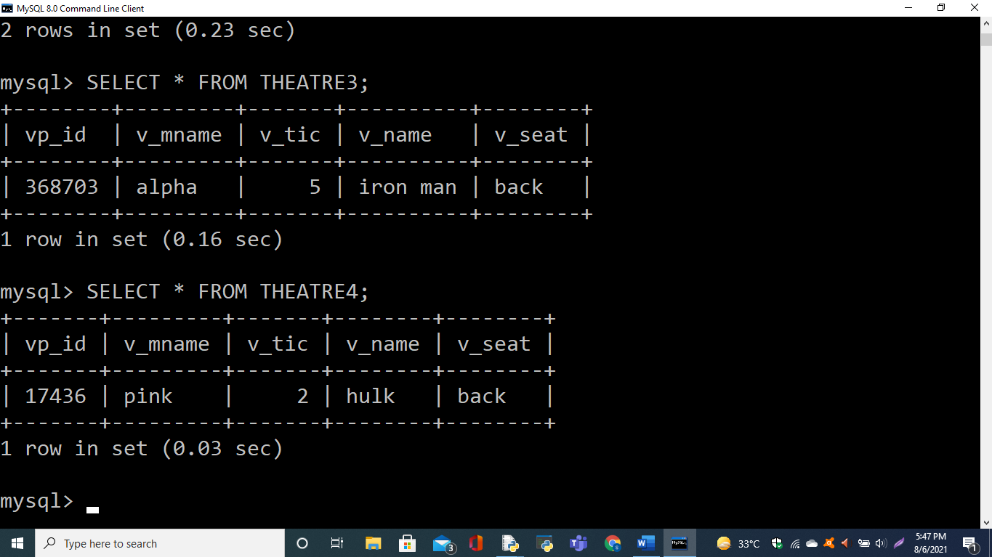

**AFTER INSERTING A RECORD IN THEATRE1 TABLE FROM PYTHON:**

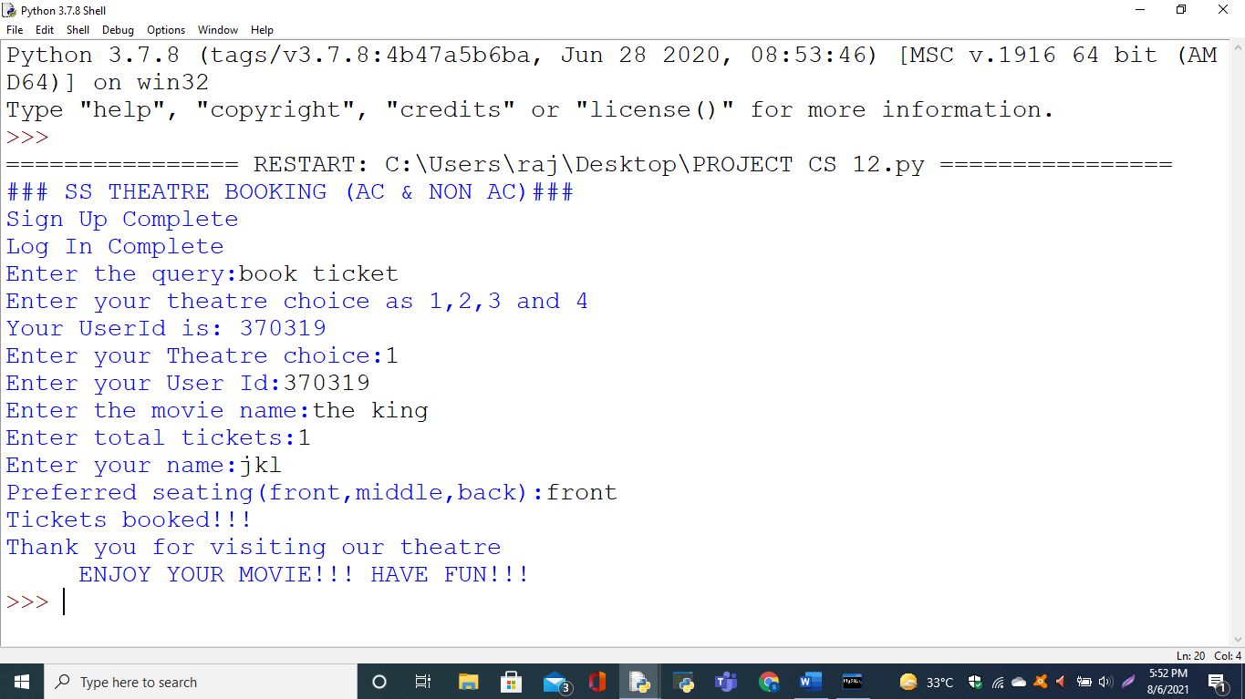

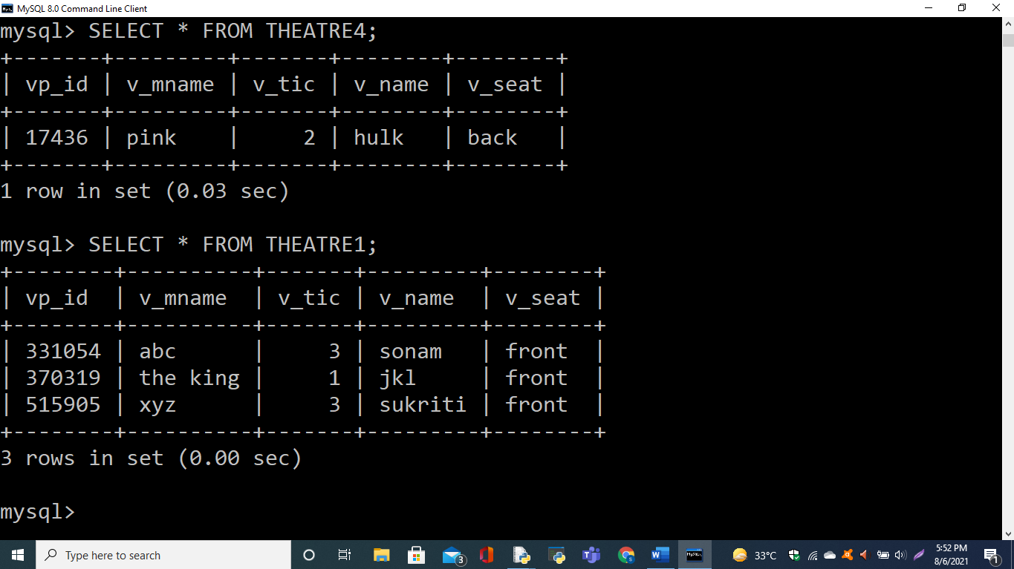

**AFTER DELETING A RECORD IN THEATRE1 TABLE FROM PYTHON:**

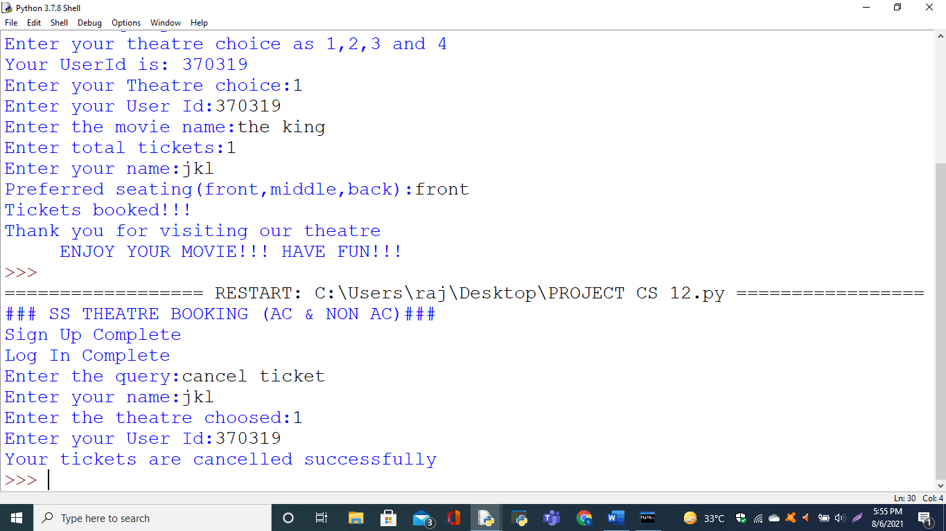

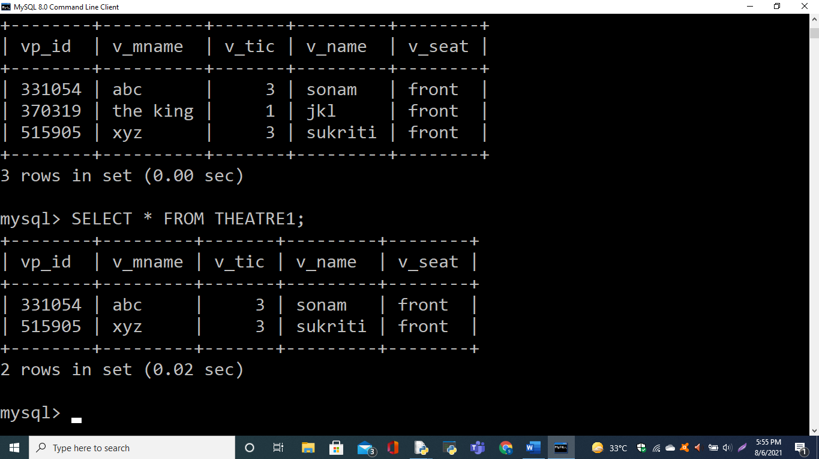

**SUMMARY**

In this project, we take some basic information about movie and user to book ticket and a user id is also provided to us. This user id is also required to cancel ticket if required. The data is stored in respective databases. Here the theatre is SS Theatre. It is a simple way to book tickets in presentative way and to store the data in a database.

In present times, where everything is digital it is a good opportunity to save time by booking tickets digitally instead of standing for hours in long queues to get tickets booked. It is very easy to book ticket digitally. Also it is very easy to cancel our ticket anytime.